UK Mindfulness Centres Collaboration
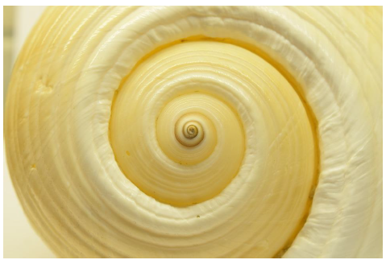

Application to train as an MBCT Supervisor in
MBCT in NHS Talking Therapies Training Programme
For supervision training online on 11th March (orientation, 4-5pm) and 3 full days from 12-14 May 2027.

Your details:
Name
Job title
NHS Talking Therapy Service
NHS Trust
Email address
Telephone number
Your qualifications and experience:
Clinical qualifications
CBT/Counselling, including other relevant qualifications

MBCT training and qualification(s)
Please include the training provider/location and when you completed the training
How many MBCT Groups have you run (teaching 50% or more if co-taught), over what period and in what context?
Please include dates (yy - yy)
How many other non MBCT Mindfulness-based groups have you run eg MBSR, MSC (teaching 50% or more if co-taught), and in what context ?
Please include dates (yy - yy)
Have you previously completed the 2 - 5 day generic NHS TT Supervision training? If yes, then when and with which organisation ?

Do you have experience of supervising others in other modalities (not MBCT) in NHS Talking Therapies services?
Yes/No
If yes, please tell us how many supervises, in what modality, if 1:1 or group supervision, and over what time period
Are you BAMBA registered?
Yes/No
Does your line manager and service lead support this training application?
Yes/No
Line Manager name and email address
Service Lead name and email address
Availability for training:
Training is likely to take place between March and June 2027. Are there any dates you would be unable to attend?
Yes/No
If yes please provide further information

When you have completed this training, how many trainees you think you could supervise from the training annually a) in your own service in your job time and b) from other services paid for by the training programme in your own time.

Additional information:
Please provide any other relevant information to support your application:

Please return your completed application to spft.smc@nhs.net and robert.marx@nhs.net by Monday 26th October 2026.

